Answers to the network management assignment

* We will use Ethernet since it’s the network standard which is adopted currently
* We will use bus topology because the buildings are bus-shaped
* We will use UTP (unshielded twisted pair) since its conventional to modern networking specially we will use CAT-6 because its CAT6 support speeds of 1 Gbps for length up to 100 meters and 10 Gbps up to 55 meters
* Installing this network will need best and affordable modern following networking devices :-

1. Modem from the ISP(internet service provider)

2. Cisco Router for connection sharing , content and network filtering etc.

3. 48-port Cisco Switch for network distribution across the building

4. 1000+ meter UTP cable

5. RJ-45 according the number of pc and printers

6. Cable trunks after measuring distance b/n floors, rooms

7. Cable crimper and punch down

8. Toner for running cables inside the walls

9. Cable ties and tapes for cable tightening

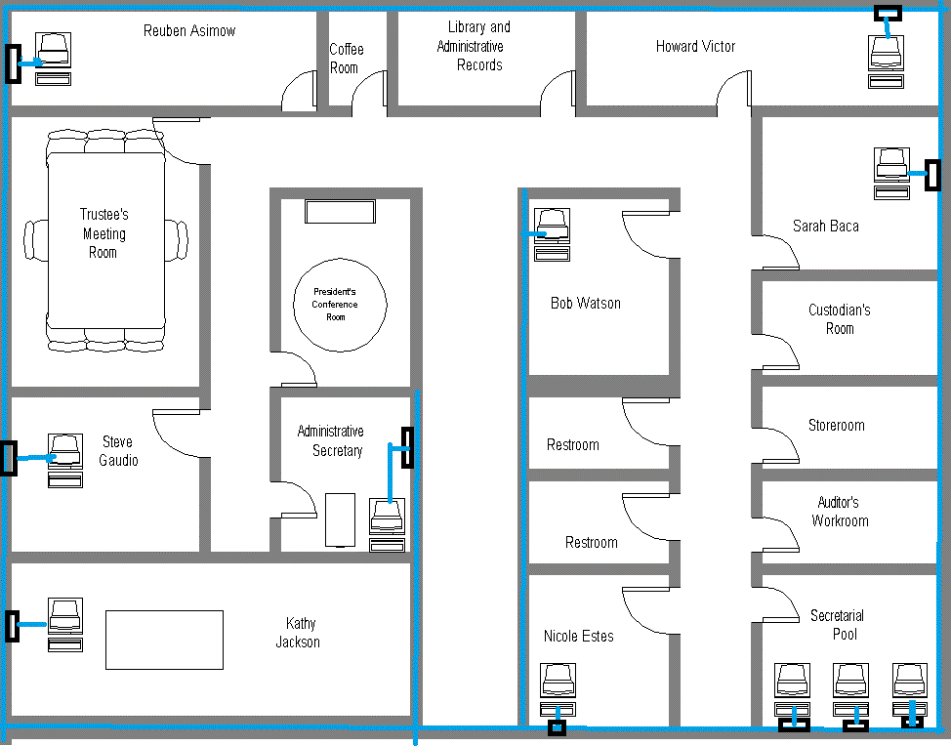1st floor network design

2nd floor network design

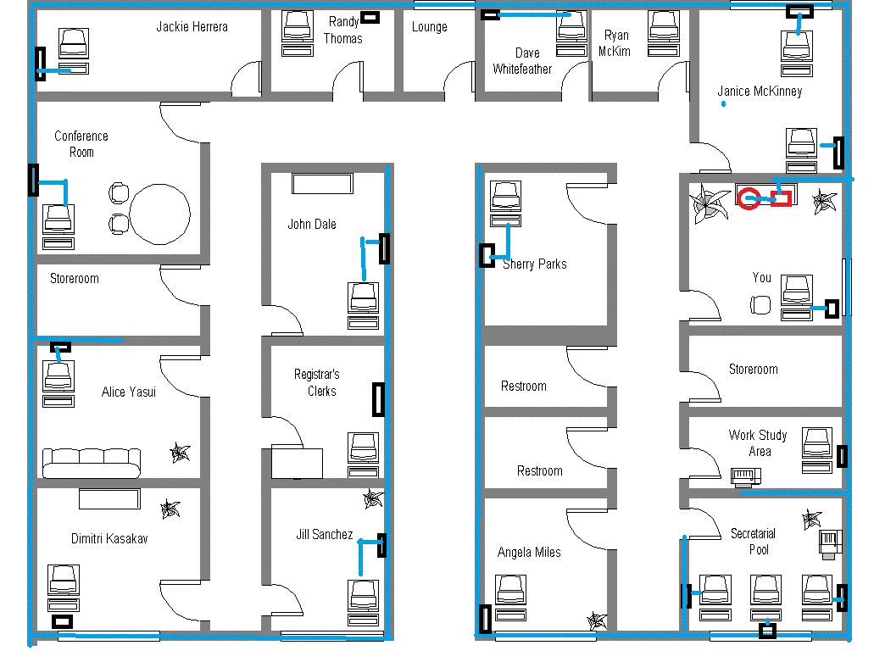

|  |  |  |  |
| --- | --- | --- | --- |
| Equipment | Cost per Unit | Number of Units | Total Cost |
| Cisco router | 30000 | 1 | 30000 |
| Cisco switch | 20000 | 1 | 20000 |
| cables | 30 | 365 | 10950 |
| RJ-45 | 10 | 100 | 1000 |